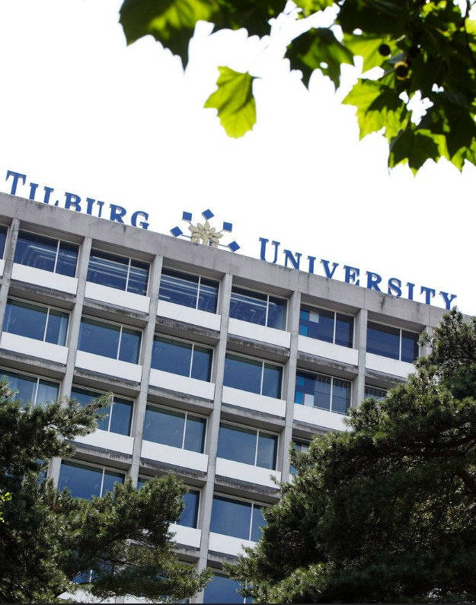

Hora Finita
Manual
PhD Candidate

Contents
1. Introduction 3
2. Practical Information 3
2.1 Check your details 3
2.2 Login to Hora Finita 4
2.3 Saving Data 5
2.4 Returning to the previous page 5
2.5 Compulsory fields 5
2.6 Disapproval 5
2.7 E-mails end up in spam 5
2.8 URL not working 6
2.9 Other IT related issues 6
3. Registration 6
3.1 Personal Information 6
3.2 PhD Track Information 8
3.3 Adding (co-)supervisors 9
3.4 Save and Submit the Registration form 10
4. Using Hora Finita 10
4.1 Explanation Dashboard 10
4.2 Using the Task Feature 12
5. Completing tasks 13
5.1 Signing the Academic Integrity Code 13
5.2 Uploading Training Supervision Plan 14
5.3 Entering courses in your Portfolio 15
5.4 Progress interviews 17
6. (Re-)submitting the Manuscript 18
6.1 Submitting 18
6.2 Re-submitting 19
6.3 Submitting the title page and requesting the Ceremony 20

Tilburg University
Hora Finita
Manual PhD Candidate
Version March 2024

1. Introduction

Hora Finita is the online system for PhD candidates at Tilburg University. All processes related to a PhD track are supported by Hora Finita: from the registration to the PhD defense. This manual will guide you through every step of the PhD track within Hora Finita.

The chapters in this manual show the global timeline and steps you will have to undertake. In the appendix, you can find more specific information about the dashboard and extensive guides with print screens of each step of the way.

If you have any questions surrounding your PhD track or Hora Finita that are not answered in this manual, feel free to contact the Key User at your Graduate School or the secretary's office of the Doctorate Board.

Graduate School | Key-user | E-mail | Phone
TiSEM | Ank Habraken | center-gs@uvt.nl | +31 (0)13 466 3102
TLS | Rowenda Makkelie | law.doctroral_degree@uvt.nl | +31 (0)13 466 8722
TSHD | Karlijn Herforth | tshd.graduateschool@uvt.nl | +31 (0)13 466 3494
TSB | Carla de Jongh | graduateschool.tsb@uvt.nl | +31 (0)13 466 2952
TST | Jack de Mooij | tst.graduateschool@uvt.nl | +31 (0)13 466 3845
DB | Tineke van Stralen | doctorate.board@uvt.nl | +31 (0)13 466 2230

2. Practical Information

2.1 Check your details

In order to get access to Hora Finita, you need the have login information from Tilburg University. If you are an internal PhD candidate, you will already have received your Administration Number (ANR) and login information from HR services. If this is not the case, please contact the Key User of your School (see 1. Introduction). If you are an external PhD candidate, or a PhD candidate on a scholarship, without an ANR, please contact the Key User of your School as well.

After you have received your ANR, together with your login information, it is necessary to check your personal details in My Employee Portal (e.g. name, birth date, address).

Tilburg University uses Multi-Factor Authentication for logging in. For more information, check https://www.tilburguniversity.edu/about/conduct-and-integrity/privacy-and-security/share-data/password/mutli-factor-authentication.

Logging in in My Employee Portal:
Go to www.tilburguniversity.edu and then click on 'Staff' in the upper right corner to enter the intranet. At the header ‘Directly to’, click on 'Employee Portal' (see next page).

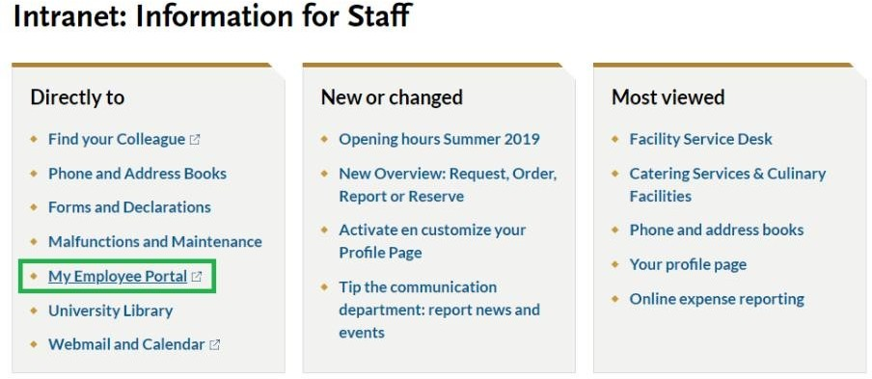
Click on "My Profile" and check your details there. Please make sure the information is correct as it is linked to Hora Finita. Correct if there are any mistakes. If there is incorrect information and you cannot change it yourself, please contact the Graduate School for support.

After you have corrected your information in My Employee Portal, it takes approximately 2 days to automatically update it in Hora Finita.

2.2 Login to Hora Finita

You can access Hora Finita through the following browsers:
- Chrome
- Firefox
- Internet Explorer
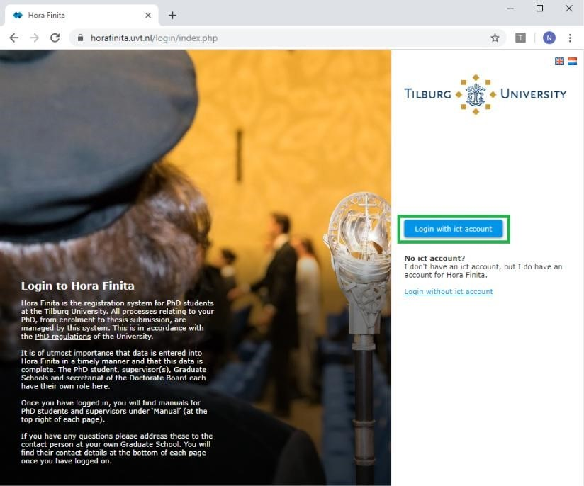
- redSafari
Your browser needs to be updated to the latest version to ensure the proper working of all functionalities.

Logging into Hora Finita:
Go to https://horafinita.uvt.nl.
- If you have a Tilburg University e-mail address, log in with your Single Sign On (SSO) information of Tilburg University by clicking on 'Login with ict account'. This requires Multi-factor authentication.
- If you don’t have a TiU e-mail address, click on 'Login without ict account', and log in with the login information which is provided by the Graduate School Officer. You will be send a security code to your personal email address.

2.3 Saving Data

All entered data need to be saved before logging off or starting another activity. The browser will NOT give a warning so all changes will be lost if you do not save it.

If you click button you return to the previous page after saving the page.
If you click button you remain on the page you have just saved.

2.4 Returning to the previous page

You have two possibilities to return to the previous page:
- By clicking on the button 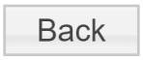
- By using the Back function of your internet browser 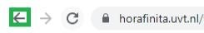

Please make sure to save all entered data and changes.

2.5 Compulsory fields

The fields marked with an asterisk (*) are compulsory. When leaving these fields empty, Hora Finita will give an error and will mark the fields that still have to be filled out in this color.

2.6 Disapproval

All the steps of this system are concluded by an approval moment. If a request is rejected the process will be suspended temporarily. The party involved (PhD candidate, supervisor, etc.) will receive an automated e-mail with all the necessary instructions.

2.7 E-mails end up in spam

It might happen that your Outlook categorizes some, or all, of the e-mails sent by Hora Finita as spam. In this case you will have to contact IT support. Give them the service desk number 19 05 00536. With this number they can find a note with the relevant information on Hora Finita and the issue you are facing. The IT team can take over your computer and correct the settings of your Outlook profile.

2.8 URL not working

Some emails you receive from Hora Finita will contain an URL. If one of these URLs does not work, please try the following solutions:

- Copy and paste the URL into the browser, and click enter.
- Disable your ad blocker and refresh the page.
- Contact IT Support as explained in 2.9 Other IT related issues .

2.9 Other IT related issues

If you would like further technical support and you are a PhD student at one of the schools of Tilburg University, please call +31 (0)13 - 466 2222

Except if you are a PhD candidate at TIAS, then please call +31 (0)13 - 466 8666

3. Registration

3.1 Personal Information

Under "Personal details", in the field "select existing person", type your ANR or last name (see 1 in the picture below). When you start typing, a drop down menu will open.
Click on your name to select it (see 2 in the picture on the right). The system does not recognize your profile if you only type in your ANR.

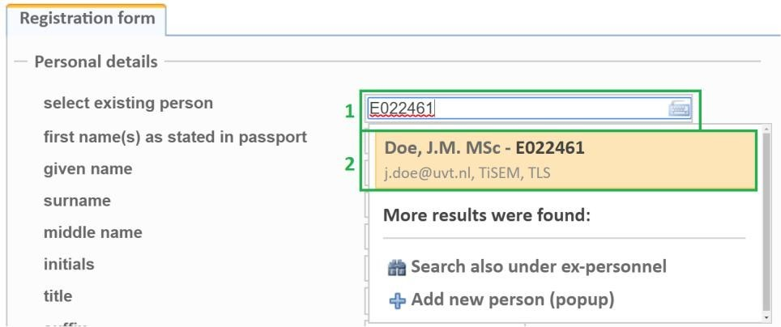
The example below shows an E-number, rather than an ANR. The E-number is used for external PhD candidates or (co-)supervisors (i.e. who are not employed by Tilburg University).

After selecting yourself, your personal information that is registered in Hora Finita will appear in the fields, as you can see in the image on the next page. If the given information is incorrect or incomplete please make the necessary adjustments.

Please make sure to add a dash "-" after the city or mobile code of your phone number. As indicated at number 1.

If your phone number is from a different country, make sure to add 00 (country code)- at the beginning. As indicated at number 2.

If the house number of your address has an addition, add it to the house number field. As indicated at number 3.

Make sure you save your data.

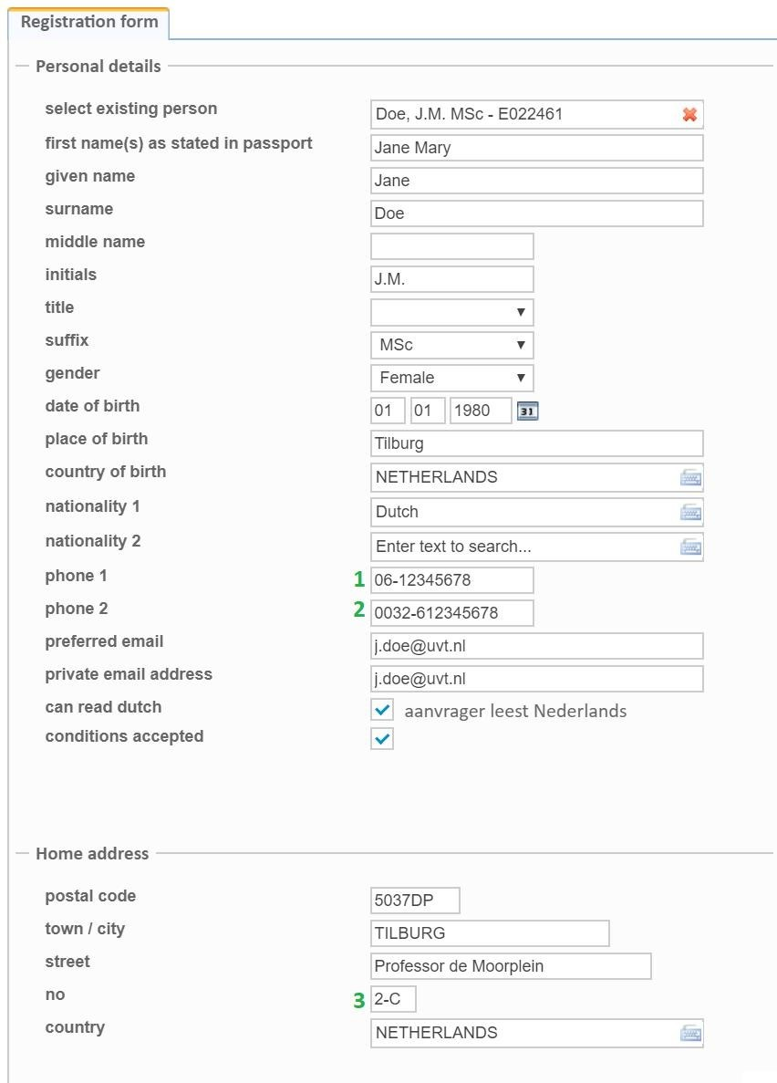

3.2 PhD Track Information

The next step is to fill out the details of your PhD track. At 1 and 2, fill in the title and description of your dissertation, respectively. At 3 you need to enter your associated faculty. When you fill out the start date at 4, Hora Finita will automatically indicate the finishing date.

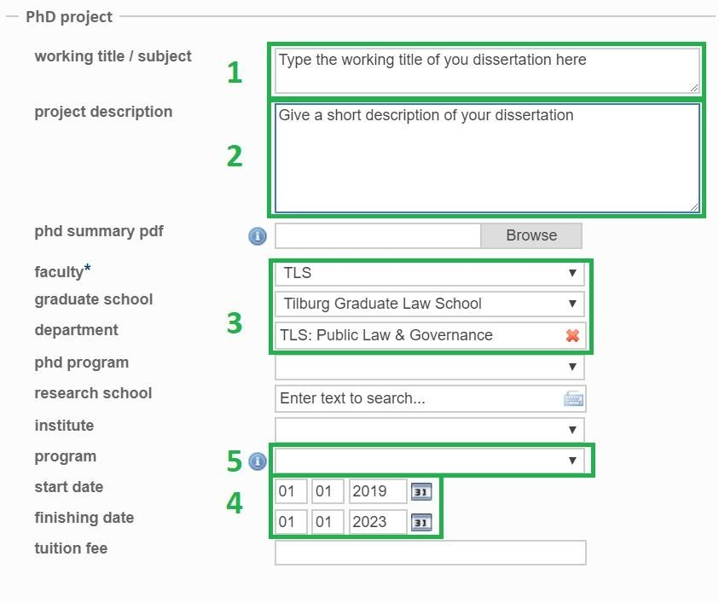
Only for TiSEM: you also have to select your program, indicated at number 5, being either Business or Economics.

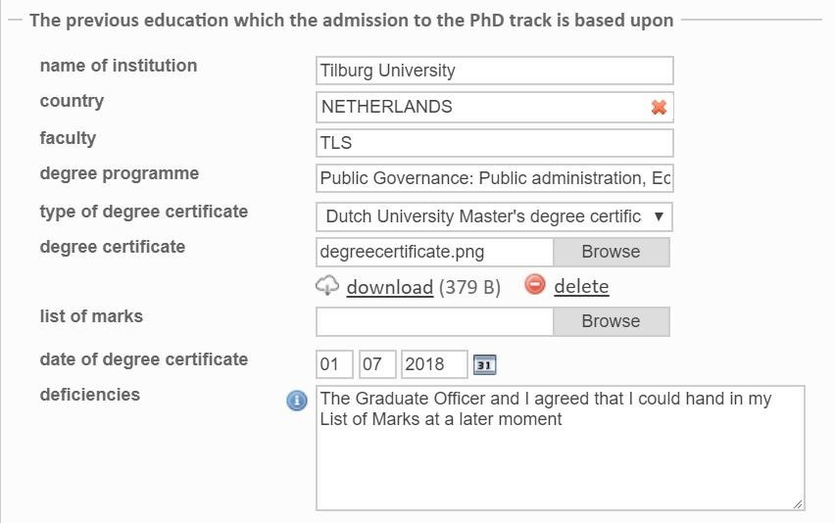
Continue with the other fields. At the "Previous education" part you have to add the documentation of your previous studies. If any of your documents are missing, please contact the Key user of your Graduate Office. Put the agreements you made regarding the missing documents in the box called "deficiencies." You are expected to upload the missing documents within the next year.If adjusted or different documents are requested, while you have already uploaded a document, click on "browse" and upload the new document. It will replace the old document automatically.

3.3 Adding (co-)supervisors

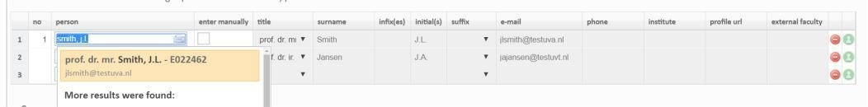
Next, add your supervisors to the form. To select your supervisor, type his/her last name and a drop down menu will appear where you can select him/her. Make sure to select the correct person.

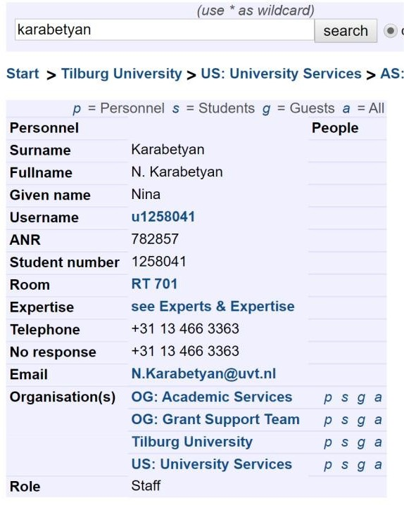
If your (co-)supervisors have a Tilburg University e-mail address, you could also use their ANR. Their ANR can be found in the online address book, https://addressbook.uvt.nl/?lan=en, by typing in their last name and click on their name. Then a table as seen below with details will appear. Copy the ANR from this table.
Type or paste the ANR in the search field, in Hora Finita, and click on the correct person. If the (co-)supervisor is an external person, who does not have an ANR, you have to search them by using their last name.

If you conclude that the supervisor is not registered in Hora Finita, you can add them manually. First, check the box indicated with 1. Subsequently fill out the information of the (co-)supervisor at 2. A functioning e-mail address is required. If you added the wrong person you can delete him/her by clicking on the red circle indicated with 3.

Repeat these steps for your other (co-)supervisors.

3.4 Save and Submit the Registration form

If you have any comments you can always use the text box. When you are done, save your data and press the button "Ready for assessment". If you need to double-check something or do not have enough time to finish it in one go, press save and continue later.

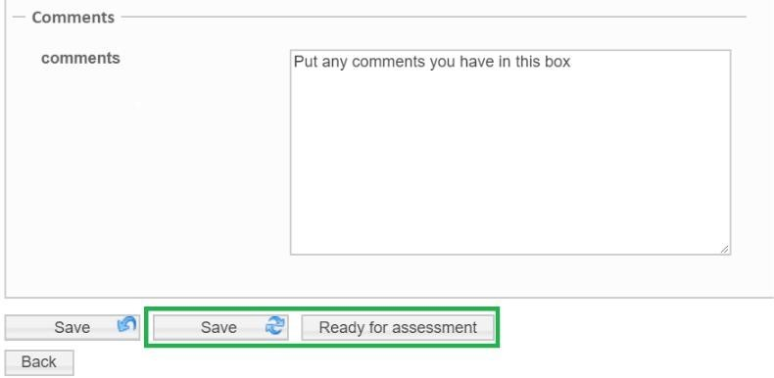
After submitting the form, it has to be approved by all (co-)supervisors, the Graduate School and the Rector Magnificus. It is possible that one of these parties requires more information from you. In that case you will receive an email with the additional information that is requested as well as the deadlines.

In case of rejection you will receive feedback via email on what you will need to improve. In case of approval you can continue with the next chapters.

Using Hora Finita

4.1 Explanation Dashboard

When logging into Hora Finita, you will be shown a dashboard with the following tabs:
Main tab "Home"
Does not contain any subtabs. The homepage consists of different useful overviews such as your latest tasks, messages and checklist.

The checklist can be found at the bottom of the webpage. If the checkmarks are green, they have been completed, and the execution date will be added in the last column. In the column "party responsible" you can see which tasks you are responsible for, and which ones have to be executed by other people. You can click on the underlined words in the checklist, to go to the right webpage where you can execute the task. If the tasks have been completed they get a green check mark, and the execution date appears.

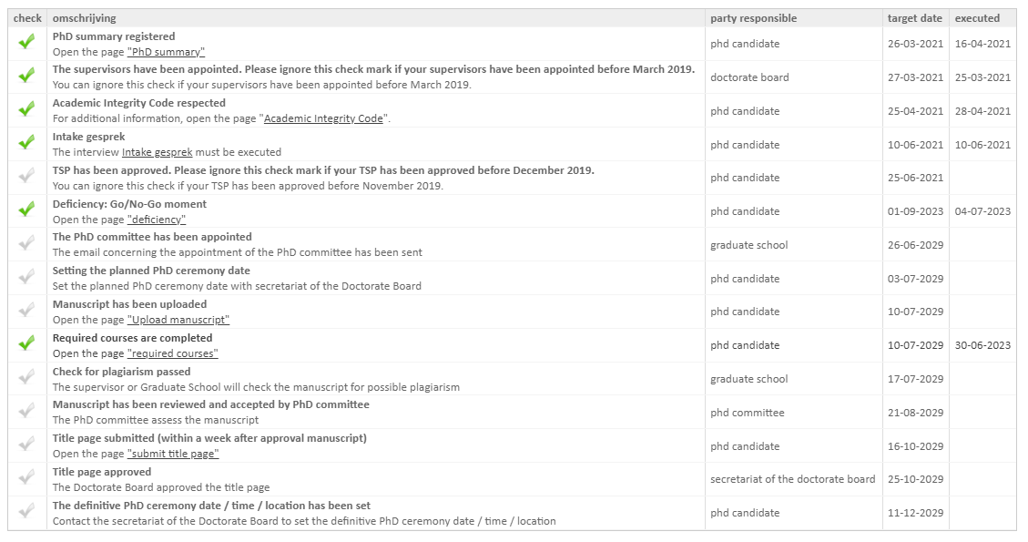
Main tab "Research phase"
TSP: Contains information on your Training and Supervision Plan
Progress interviews: Contains dates and details on your meetings with your (education coordinator or PhD Coordinator.
Required courses: Shows the status of the Face to face and Online Training Research Integrity.
Training activities: Upload information on your followed courses here.
Questionnaires: Tilburg University currently does not use this feature.
Print progress file: Clicking on this results in a PDF file with your progress details.
Main tab "Graduation phase"
Upload Manuscript and Request PhD ceremony: Officially upload your manuscript here.
Upload modified manuscript: If your initial manuscript is rejected, you can upload a new version here. This tab will appear after you have uploaded your first version of the manuscript.
Submit title page: Submit your title page here.
Main tab "My PhD"
My details: Contains your personal information
Upload certificate: You can upload your previous degree here.
Pledge: Contains information on the Academic Integrity Code
PhD summary: Contains the summary of your PhD track
Documents: Contains all documents associated with your PhD track.
Main tab "Support"
Here you can find relevant information such as PhD documents and contact information.

4.2 Using the Task Feature

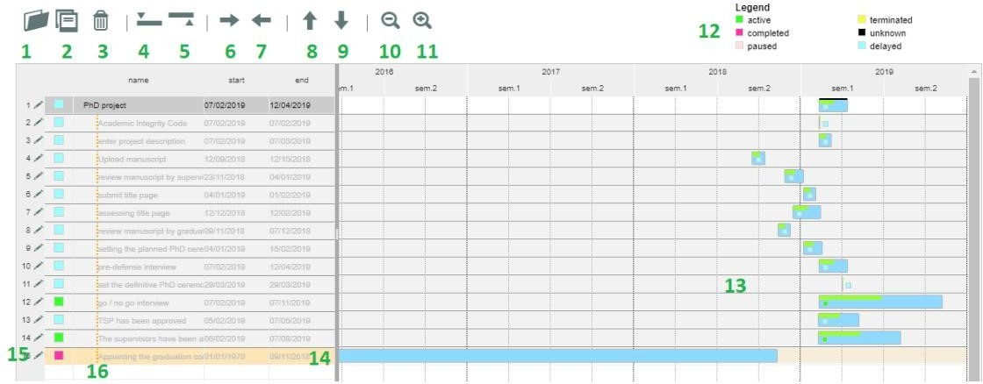
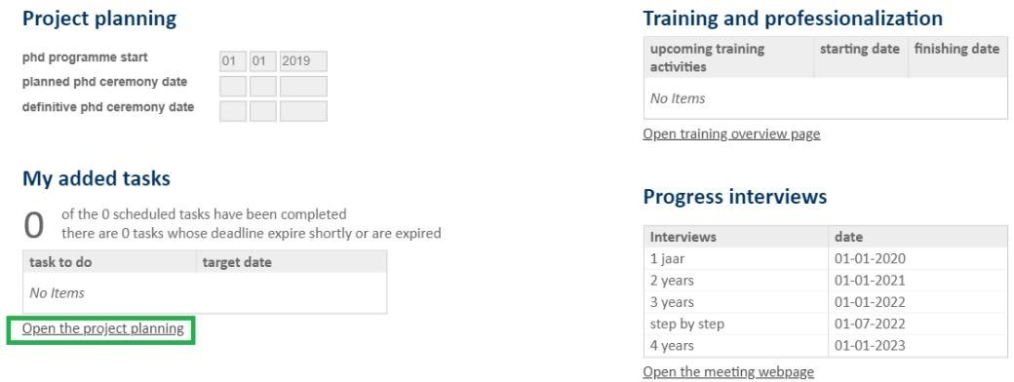
The homepage shows you a general overview of your progress and planning. At the dashboard, under the heading “My added tasks”, You can add tasks to help you structure your PhD track. Click on "open the project planning".

Here you can find an overview of your tasks. The Graduate Officer is able to add tasks as well. Make sure to check your planning regularly.

1: Library with predefined tasks. If you select the task(s) you want to add, scroll down and press "Add", they will appear in the timeline.
2: Save button
3: Delete button. Click on the task you want to delete and then click the button.
4: Adds a new task above the task you have selected.
5: Adds a new task below the task you have selected.
6: Indents the task, to show that it is linked to an overarching task.
7: Reverses the indent.
8: Moves task up (including indented tasks below it).
9: Moves task down (including indented tasks below it).
10: Zoom in function.
11: Zoom out function.
12: Legend which represents the colors in the timetable.
13: Timetable.
14: The dates and task name can be changed by clicking on them.
15: The task can be changed by clicking on this pen.
16: A new task can be added by clicking on the empty line.

Completing tasks

5.1 Signing the Academic Integrity Code

First you need to digitally sign the Academic Integrity Code.
You can find the information in the top menu when you login, under "My PhD" and then "Pledge"

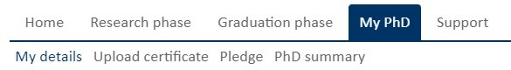

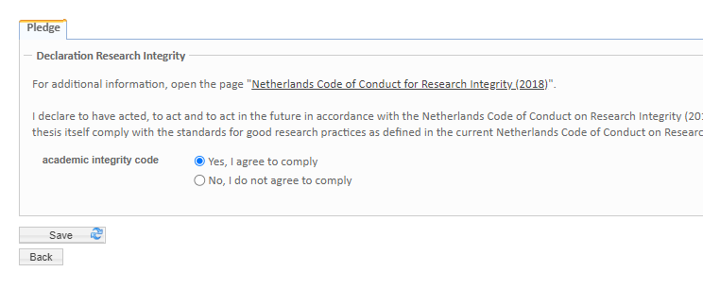
You can find the document with the complete Academic Integrity Code by clicking on the link. After you have read and understood the Academic integrity Code you can sign the pledge by selecting "yes, I agree to comply". Click save when you are done.

5.2 Uploading Training Supervision Plan

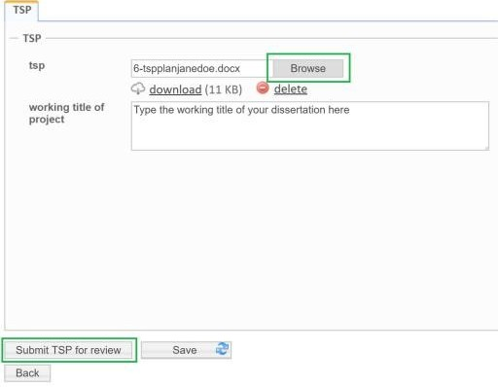
At the tab “Research phase” and then “TSP” you must upload your Training Supervision Plan. Click on “Browse”, fill in the working title of your dissertation, and then press “Submit TSP for review”.

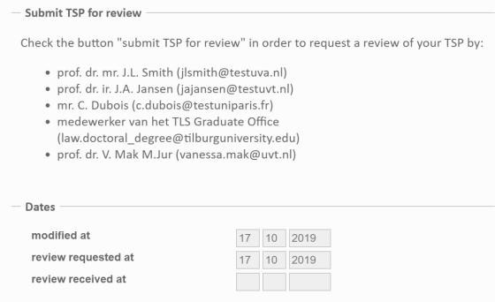
After you have pressed submit, the dates in these boxes will automatically be filled out.
If your TSP has not been approved, you will receive an email with the comments. Change the document accordingly and re-upload it via your dashboard. Retake the steps as explained above.

If your TSP has been approved, you will receive an e-mail with the approval, as well as any comments that have been added. Within your dashboard you can also find these comments under the same tab “TSP”.

Your TSP has to be updated and approved every year. To upload a new TSP, click “browse” and then "submit TSP for review".

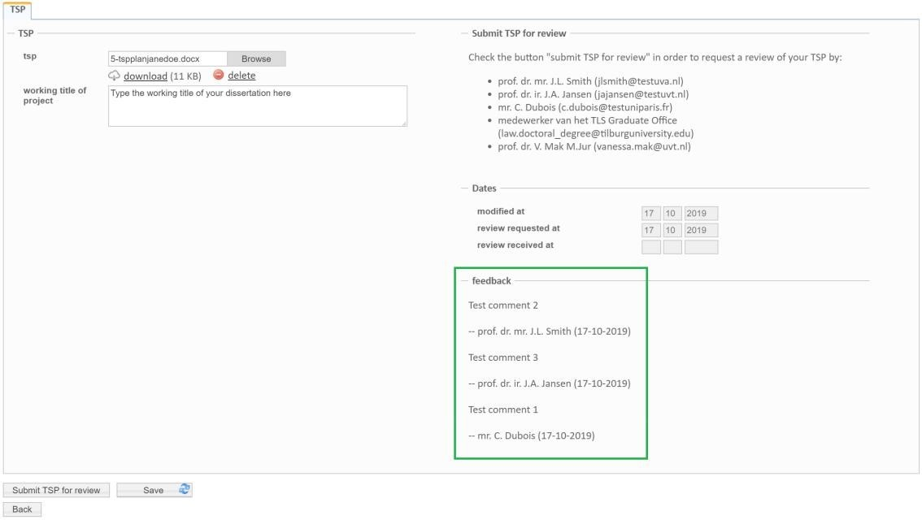
Please do not forget to enter the courses included in your TSP in your portfolio as well, as explained in 5.3.

5.3 Entering courses in your Portfolio

Under the main tab "Research phase" you can find the sub tab "Training activities". You can input all the activities from your TSP on this webpage, including the mandatory research integrity trainings.
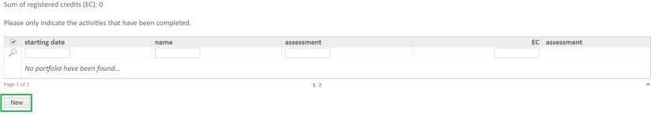

Click on "New" to add a new training or course. Choose the type of activity from the drop down menu, and fill out the rest of the information.
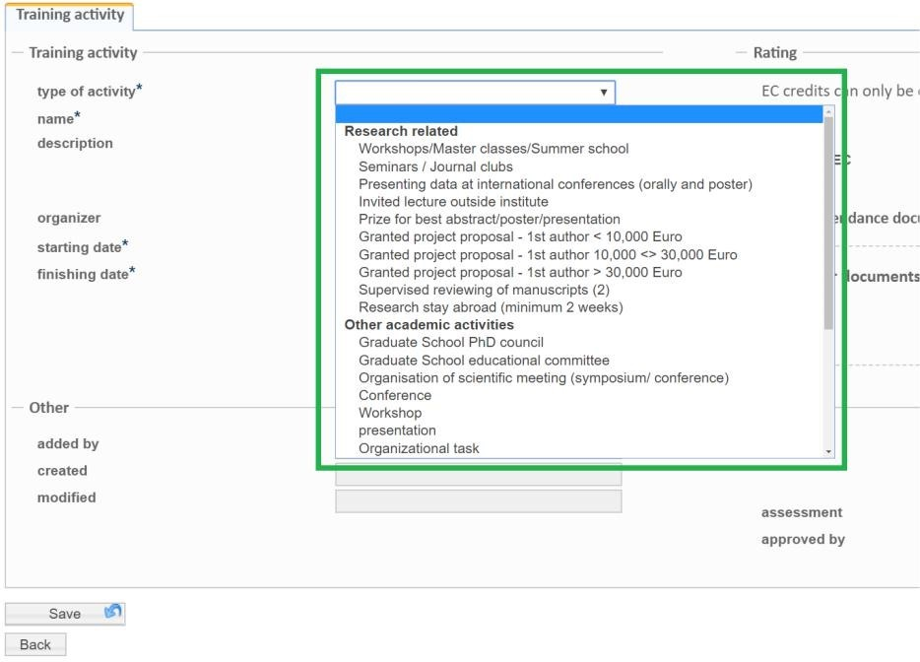
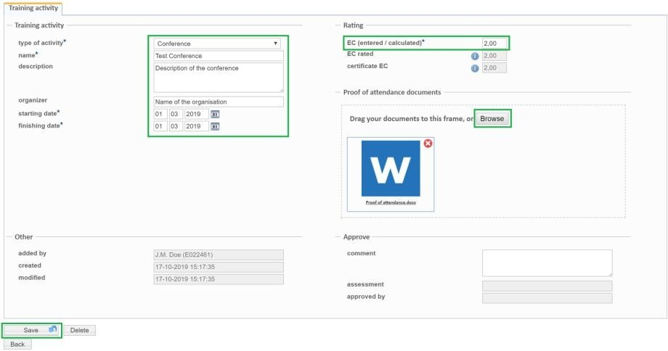
Fill out all the information, including the dates and EC of the activity. You can also upload documents such as certificates, or presentations as proof of attendance. If you want to upload multiple documents, you first have to merge those documents.

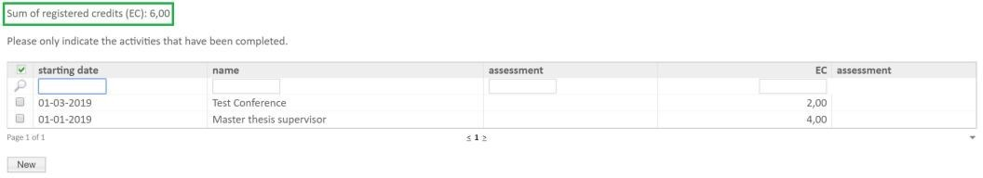
After you have added the training activities, they will appear in the subtab portfolio as follows. Above the table you can find the total number of ECs you have gathered.

5.4 Progress interviews

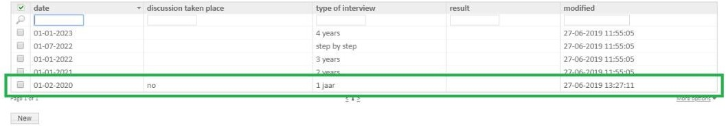
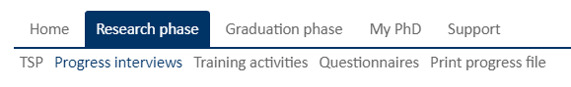
Under the main tab "Research phase" and then at the subtab "Progress interviews", you may find your standard scheduled meetings with your PhD coordinator or Education Coordinator (for TiSEM). You can view the details of a meeting by clicking on the meeting in the table.

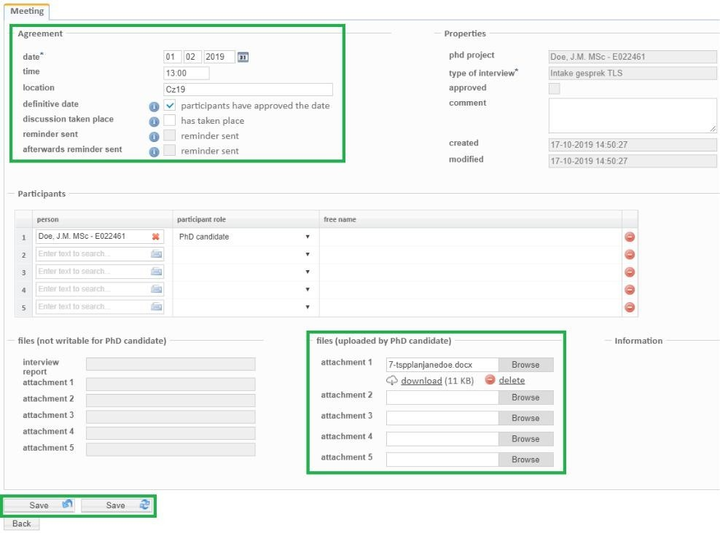
Here you can find all the relevant information about the meeting. The PhD Coordinator or Education Coordinator will fill out all the information. You only have to upload the relevant documents. Click on save when done.

After the meeting the PhD Coordinator or Education Coordinator will upload the meeting report to Hora Finita, which you can access through this page. The "has taken place" box will be ticked off when the date has passed, and the report is uploaded. If you wish to have extra meetings, please contact your PhD Coordinator or Education Coordinator

6. (Re-)submitting the Manuscript

6.1 Submitting

In your dashboard, under the tab "Graduation Phase" and then at the subtab "Upload manuscript and request PhD ceremony" you can upload the final version of the title and your manuscript.

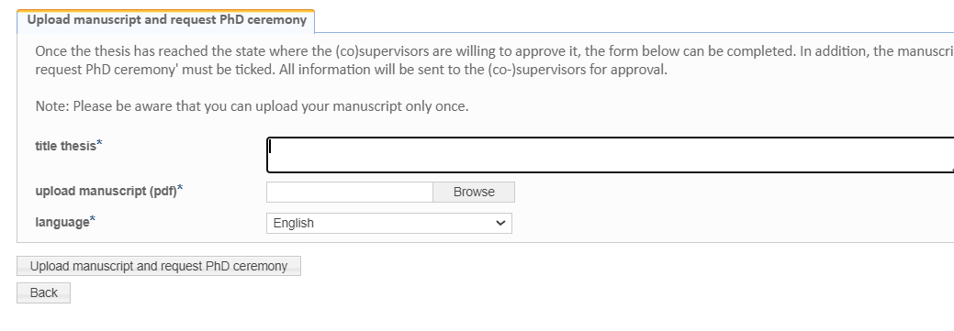
Fill out your final title, and upload the document by clicking on browse. Please note that the maximum size of the file is 200Mb. Moreover, note that you do not have to conduct a plagiarism scan yourself. The Graduate Officer will execute this.

After you press “Upload manuscript and request PhD ceremony”, please wait until all supervisors have finished the assessment. Do not upload a new manuscript until they have finished assessing your manuscript.

The deadline for your supervisors to check your manuscript is 4 weeks. You will be notified via e-mail whether it has been approved.

TiSEM: After approval of the manuscript a predefense will take place. The (co-)supervisors are responsible for the execution of the predefense. You will receive an email with instructions. Afterwards you will need to write a predefense report.

Other Schools: After approval the manuscript will automatically be sent to the PhD Committee. If your manuscript has been approved, continue to 6.3 Submitting the title page and requesting the Ceremony. In the case of rejection, your (co-)supervisor(s) will contact you.

6.2 Re-submitting

If your manuscript has been rejected, you have to upload a modified manuscript. This tab appears after the first manuscript has been uploaded. Click on the tab "Graduation phase" and then on "Upload modified manuscript".

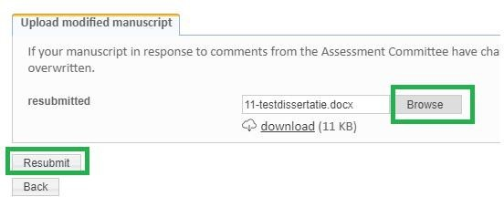
Click on browse to select the right document, and after you are done click on “Resubmit”. Your (co-)supervisors will receive a new request to check the manuscript.

You will again receive the outcome via e-mail.

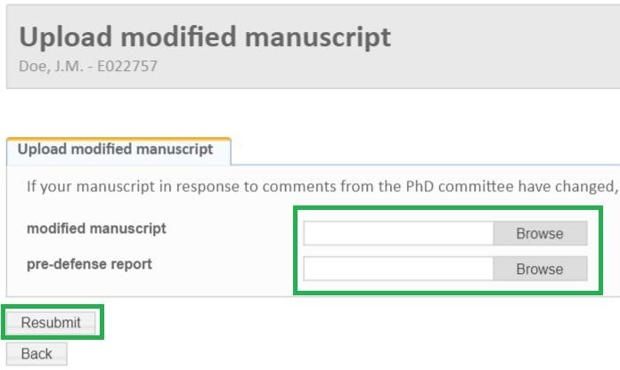
TiSEM: TiSEM PhD candidates have to upload the modified manuscript as well as the pre-defense report.

6.3 Submitting the title page and requesting the Ceremony

After your manuscript has been approved, you will have to take a few more steps: submit your title page and request the ceremony.

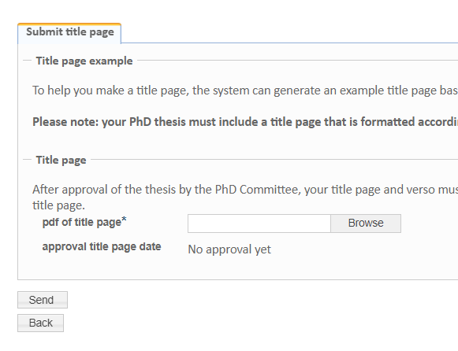
Under the tab "Graduation phase" and then at "Submit title page", you can upload your title page. Click on "browse", select the correct document and click on save.
The ceremony has to be requested by contacting the Doctorate Board (doctorate.board@tilburguniversity.edu). Together you will look for a suitable date, after which the secretary's office will make it known to all the relevant parties.

