Procedure Ethics Review Board TLS

Introduction
This memo explains in short the work of the Ethics Review Board of TLS (ERB-TLS). Tilburg University has decided on an integrated approach ‘one-stop shop’, combining ethics review with data management and registration of use of personal data as required by the General Data Protection Regulation (GDPR). By combining these three aspects the workload for researchers will be limited as much as possible. To that end, an application form has been developed that integrates Ethics Review, Data Management and Registration. More information can be found on the GDPR website, and the ERB-TLS website.

Why ethics review?
Any research in social and behavioral sciences, in the humanities and in law that creates (a risk of) harm to human research participants (respondents, test persons, etc.) or that can be harmful by design or potential outcome, is to be guided by ethical principles. In following these, we need to acknowledge and manage risks to participants’ wellbeing that might arise in the research.
In an academic environment in which research is increasingly interdisciplinary and empirical research increasingly important including within the legal discipline, researchers ought to be aware of ethical aspects of their research. The ERB-TLS through ethics review gives guidance to researchers on the ethical aspects of their research and provides ethical clearance if the research will be conducted in compliance with its guidelines. Such clearance might even be required for publication of the research results or when applying for funding.
The conduct of ethical research is and remains in the first place the responsibility of the researcher. The Ethics Review Board aims at providing guidance for researchers by:
- Assisting researchers in self evaluating the ethical issues involved in their research
- Assessing whether research proposals are in compliance with ethics guidelines
To that goal, the ERB-TLS provides accessible tools (e.g. checklists) for researchers for self-evaluation and has set up an efficient procedure for the assessment of research proposals.
The responsibility of the researchers does not end when the study receives ethics approval but continues for the entire lifecycle of the research.

Research ethics Guidelines and Legal Frameworks
Research within Tilburg Law School should be in compliance with:
- The Netherlands Code of conduct for Academic Practice
- Wet medisch-wetenschappelijk onderzoek met mensen
- Regulation (EU) 2016/679 of the European Parliament and of the Council of 27 April 2016 on the protection of natural persons with regard to the processing of personal data and on the free movement of such data
- Dutch Law Personal Data (Uitvoeringswet Algemene verordening gegevensbescherming) (forthcoming 2018)
These documents form the basis of the ethics review within Tilburg Law School.

Which research needs to be reviewed?
All research that may be harmful or creates a risk of harm to research subjects, in particular (but not exclusively) humans, e.g., subjects of experiments, respondents to questionnaires, interviewees, etc.) should be reviewed.
According to the definition as given by Joel Feinberg (1984) harms are to be regarded as ‘setbacks to/of interests’. At least there is a risk of harm when:
- The research involves vulnerable groups such as children, patients, people subject to discrimination, minorities, people unable to give consent, people of dissenting opinion, immigrant or minority communities, sex workers, etc. Experts, for example judges or police officers, are not considered to be a vulnerable group unless disclosure of the data collected can put them in a vulnerable position.
- The research involves sensitive data. Sensitive data are personal data revealing, among others, racial or ethnic origin, political opinions, religious or philosophical beliefs, or memberships (e.g. of trade unions), and the processing of genetic data, biometric data for the purpose of uniquely identifying a natural person, data concerning health or data concerning a natural person’s sex life or sexual orientation.
- The characteristics of the research design itself are endangering to participants, or there is a risk that results will be abused by third parties. While these situations are less likely than those listed under A. and B., researchers should be aware of potential harm in these situations.
The researcher needs to reduce the risk of potential harm (a non-exhaustive list of examples is provided below) and prevent harm to the respondents that is posed by the research. When risk of potential harm is too high, no benefits of the research can ethically justify the research methods. The researcher has to explain how to mitigate risks of harm.
If there is still doubt about the need for a review, send us an e-mail with a short description of the research design (ERB-TLS@uvt.nl) so we can determine whether or not your research should be reviewed.
List (non-exhaustive) of examples of harm:
- Physical pain, injury, illness or discomfort
- Emotional distress or cognitive disturbance
- Public exposure / exposure to third persons without consent
- Tacit forwarding of data to third persons or organizations
- Unfair discrimination on the basis of ethnicity, religious belief, gender, sexual preferences, age, disability, cultural or linguistic community
- Long term mental and physical health damage
- Abuse of financial or economical setbacks
- Impediments of autonomous decision-making, e.g. by providing insufficient or insufficiently comprehensible information about the set-up, the goals and the reasons of the research
- Sexual harassment
- Intimidating behavior and undue influence, e.g. in hierarchical relationships
- Hiding conflicts of interests or (multiple) relationships
- Participating in, facilitating, assisting, or otherwise engaging in torture, or any cruel, degrading behavior
- Manipulation of behavior or responses other than accounted for in experimental design
- Unlimited demands of time and effort
- Negligent or sloppy design and practice of data gathering, including selecting research subjects without checking their (health) condition
- Withholding data / findings relevant to the well-being of research subjects
In some cases one also has to curb disproportional profit
- Excessive financial rewards
- Waivers for basic educational requirements
- Testimonies and recommendations beyond the skills tested and proved, e.g. in social media
- Privileged access to scarce resources that should be distributed by parameters other than being (having been) a research subject.

How to submit?
- The applicant fills out the standard application form.
- The applicant submits the form by sending an e-mail to ERB-TLS@uvt.nl. The applicant includes, if applicable, the following information:
  - The text used to recruit participants for the study (if applicable);
  - The written information about the study that is provided to the participants;
  - Informed consent forms for all parties involved;
  - Questionnaire’s
  - The text of the debriefing material (at the end of the data collection);
  - Evidence of approval from relevant external institutions to conduct the study (if applicable),
- The Ethics Review Board will assess the submission. The Ethics Review Board meets once a month, either physically or virtually.
- Based on A, B, and C above the Ethics Review Board decides whether ethical clearance can be granted or not. If not, the ERB explains why.

Remarks with regard to Data management and the GDPR:
- All researchers fill out the data management questions of the integrated application form, in accordance with TiU regulations on data management. This includes researchers who do not collect empirical data, and research that does not require ethics approval.
- All researchers who deal with personal data fill out the GDPR part of the registration.
- In accordance with the Research Data Office (RDO), the TLS-ERB recommends storing (personal) data in either the M or O drive. When sharing data with externals we recommend using Surfdrive.
- More information can be found on the website provided by LIS/RDO.

Other Remarks:
- Clearance is given to the study as specified in the submission. Changes to studies after clearance has been obtained cannot be made unless they involve aspects that do not have implications for the research ethical aspects of the study.
- Clearance cannot be obtained after a study has been conducted. Only in specific cases (on a tailor made basis) can a form of retroactive clearance be granted. For more information, contact the ERB.
- Students and PhD candidates should ask their supervisor to be the first applicant for the submission.

Timeline and other practicalities:
- The ERB-TLS strives to complete the procedure for receiving ethical clearance within three weeks after a complete application file has been submitted.
- The ERB-TLS does not require an in-depth explanation of the theoretical/methodological background of a research project. Please keep it as succinct as possible.

Flowchart procedure ERB (Ethics, data management and GDPR)
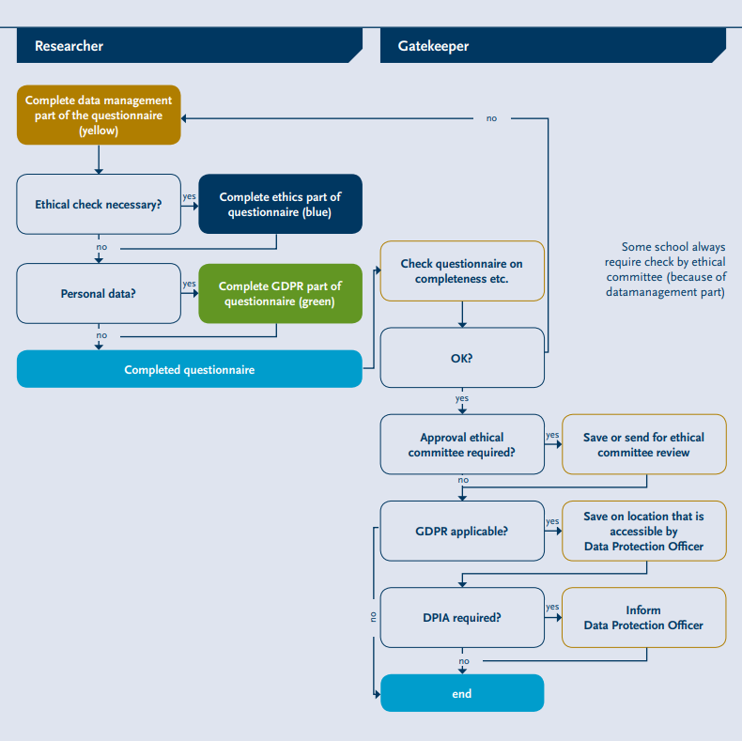

http://www.vsnu.nl/files/documenten/Domeinen/Onderzoek/The_Netherlands_Code%20of_Conduct_for_Academic_Practice_2004_(version2014).pdf
http://wetten.overheid.nl/BWBR0009408/2017-03-01
http://ec.europa.eu/justice/data-protection/reform/files/regulation_oj_en.pdf
Joel Feinberg; The Moral Limits of the Criminal Law, vol. I Harm to Others (1984) 31ff
According to the Regulation (EU) 2016/679 of the European Parliament and of the Council of 27 April 2016 on the protection of natural persons with regard to the processing of personal data and on the free movement of such data, and repealing Directive 95/46/EC
According to the Regulation (EU) 2016/679 of the European Parliament and of the Council of 27 April 2016 on the protection of natural persons with regard to the processing of personal data and on the free movement of such data, and repealing Directive 95/46/EC, article 9

