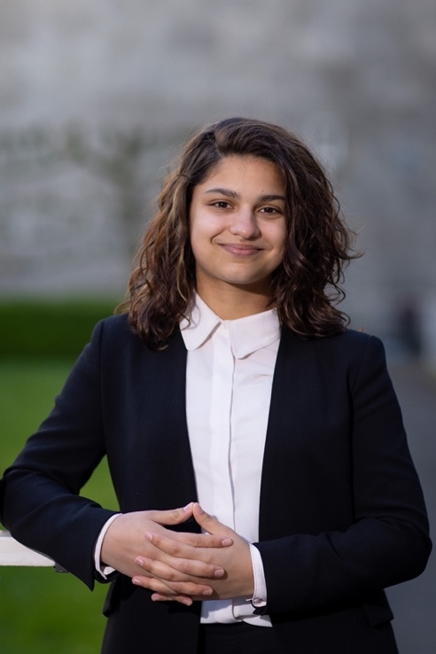  Picture | Student Party Stimulus | Position on list: 1
Name candidate:
Naomi de Leng

Hi friends! :)
My name is Naomi (she/her), I am 21 years old and currently a third year Psychology student. Next year I will be doing the Research Master in the Social and Behavioral Sciences.
I joined Stimulus this year because I am really passionate about giving back to my community. I feel strongly about standing up for others, and I believe it is a very valuable opportunity to be the voice that represents our current and future generation of TSB students. I already like to help my fellow peers whenever I can, but with this position at Stimulus I will be able to really make a difference and strive for improvements where students want to see them.
My focus points will be on the development of hybrid education, including hybrid forms of examination, as well as improving the course programs, by e.g., creating more opportunities for critical thinking and writing skills that you will need throughout your career and further education.

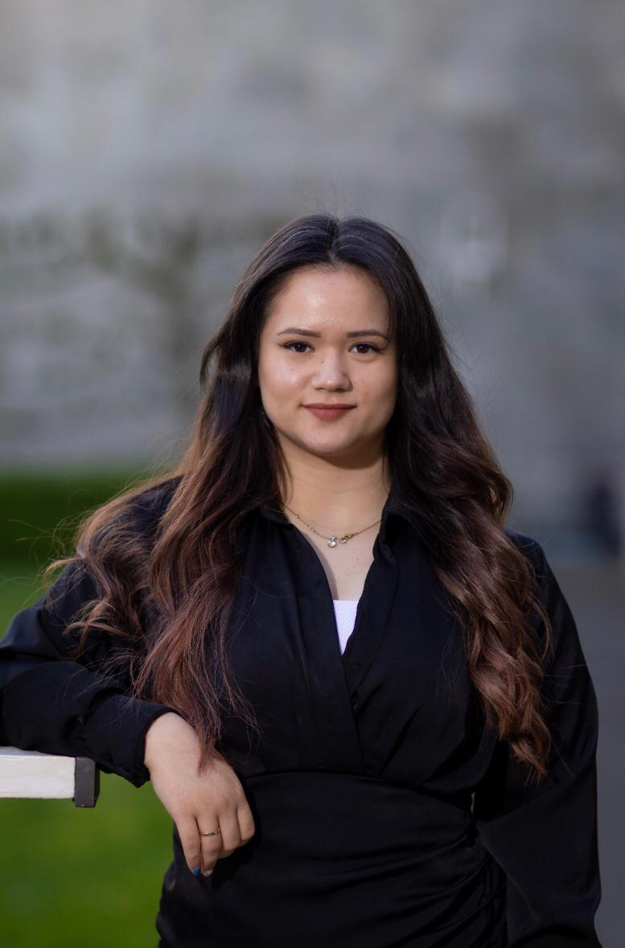  Picture | Student Party Stimulus | Position on list: 2
Name candidate:
Aysun Hasan

Hello everyone!
I am Aysun Hasan, a 19-year-old Bulgarian girl with Turkish origins. I am a first-year HR student at Tilburg University. Besides studying, I love travelling, shopping, reading self-help books, meeting new people, walking around nature while taking some time to unwind and etc. This upcoming year as a board member of Stimulus, I want to represent you - TSB students, so that together we can create a change for the better. I believe that I am in the right place as I am ready to listen, critically evaluate and find solutions and ways to develop. My personal focus will be on improving PASS, enhancing the onboarding for first-year students and enhancing support. I am #2 on the list for the TSB faculty council elections for which you can vote on 12, 13, 14 of April. Hopefully, I can count on your vote as I am really enthusiastic about representing you next year!

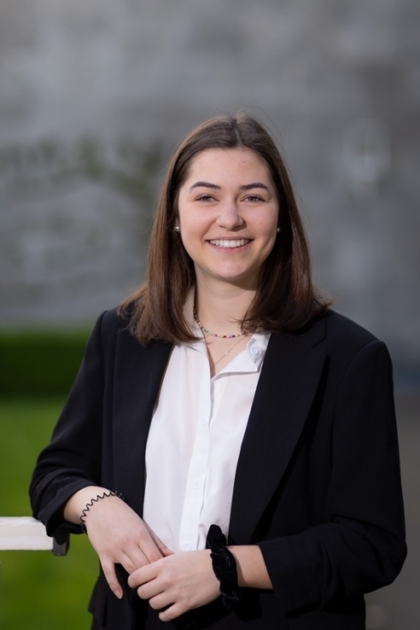  Picture | Student Party Stimulus | Position on list: 3
Name candidate:
Henryetta Paleit

Hey all, let me introduce myself. I am Henryetta, 20 years old and an international student from Germany. I am about to finish my second year of psychology in the Economic psychology major. Besides studying I am a PASS student mentor, a mentor for exchange students at ESN and I enjoy playing hockey at the student association SHOT.
Why should you vote for me?
I am an ambitious and goal-oriented student with prior experience as a student representative as this will be my second year at Stimulus. Personally, this year I want to look more into the labor market relevance and make career support services for students more accessible. With the help of your vote, I am sure we can achieve great things together the upcoming year! So, make sure to vote for Stimulus on April 12, 13 and 14!
Feel free to reach out to me for any questions that you might have about the elections or Stimulus in general.

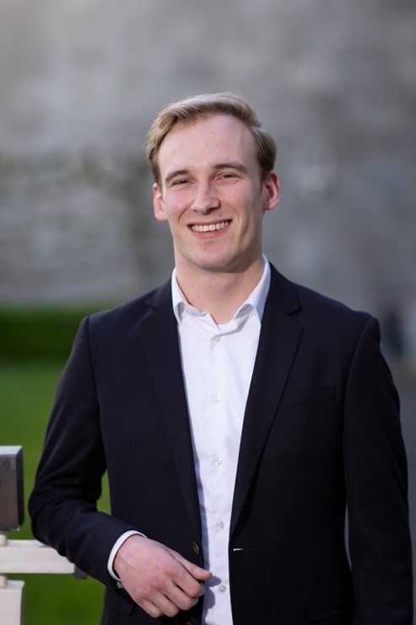  Picture | Student Party Stimulus | Position on list: 4
Name candidate:
Joep Tielemans

Hi! I’m Joep Tielemans, I am in my first year of the bachelor Psychology and I hope that someday I will be of great help to people with mental illnesses. In my free time you will often find me hanging out with my friends. The rest of my time I spend reading and listening to music. I would like to see TSB make best use of the available possibilities that arise. For example, covid got us locked up for a long time and on campus college is important, but I also think that online lectures give us a great opportunity to improve education. (Crises precipitate change). Other than that, I feel like there is room for progress in internationalization and transparency. I hope to achieve these goals and for that, your vote would be of great help! So please vote for Stimulus on 12-14th April! Feel free to ask questions if you have any!

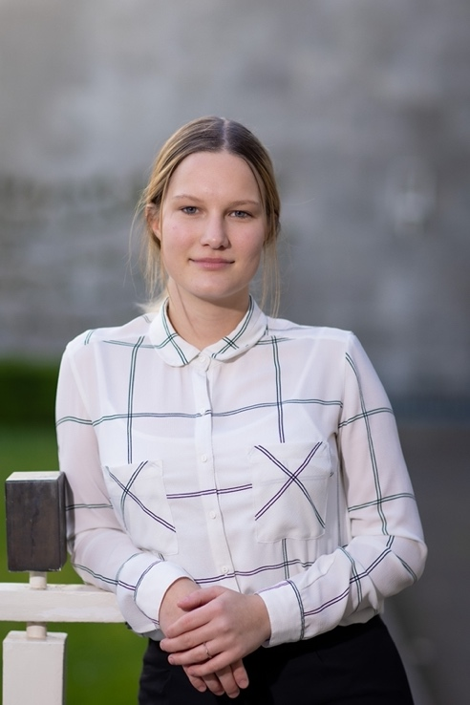  Picture | Student Party Stimulus | Position on list: 5
Name candidate:
Maxine Große

I am Maxine Große, a 19-year-old psychology student majoring in clinical psychology. Originally, I am from Germany, but I have experienced life abroad both in Asia and in the United States. As a determined and open-minded student, I ensured to take in as many experiences as possible and to take advantage of opportunities that come my way. As a current Stimulus board member, I was able to coordinate the International Advisory Group and have an influence on the evaluation of the Code of Conduct. I also have the honor of representing TSB students for another academic year and I look forward to increasing the impact me and my board have.

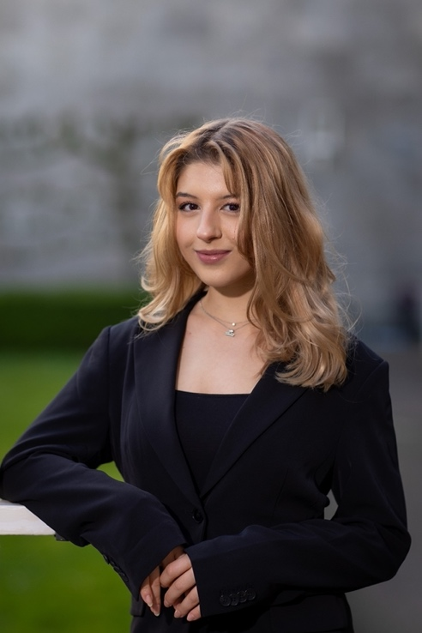  Picture | Student Party Stimulus | Position on list: 6
Name candidate:
Ilayda Siner

I am Ilayda Siner, a third-year psychology student. Aside from having completed two board years at the TSTV Saltare, and working as an international student recruiter at Tilburg University, I am also completing a research internship at the Go-Lab alongside my board year at student party stimulus. This year, once again, I am on the list as #6! I could not be more ecstatic to have the opportunity to further develop our initiatives for another year, and to be able to represent all TSB students. My goal is to establish more help and preparation for international students with regards to navigating living in the Netherlands, whether it be regarding the (mental) healthcare system, or the job market. A great point of focus for me is the mental health of students. During my board year at Stimulus, we have made progress within this goal through creating a guide for students, and through the ongoing organization of mental health events in collaboration with TSB Platform. I would be honored to continue to create change within our faculty, and be the listening ear and voice for you.

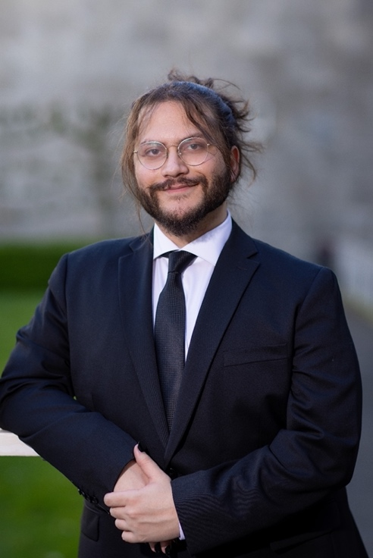  Picture | Student Party Stimulus | Position on list: 7
Name candidate:
Berkay Caglayan

I’m Berkay Caglayan, a third-year BSc Psychology student at Tilburg University. When I am not focused on my studies, I like making music, cooking new recipes, playing guitar, and connecting with new people. Being an international student and having lived through the struggles that come with it, I am familiar with the issues that other students like me are faced with. My goal is to make sure that international students have easy access to all the tools and information they need to make their integration in life as seamless as possible, both in and out of university. Another point that I deeply care about is the mental health of all students. As we collectively keep going through this time of trauma, I noticed that there needs to be a stronger focus in supporting students, with more available resources. I am looking forward to representing you this year!

